

Semester Two Examination, 2024
Question/Answer booklet

MATHEMATICS
METHODS
UNITS 3&4

SOLUTIONS
Section Two:
Calculator-assumed
WA student number: In figures

In words

Your name
Number of additional
answer booklets used
(if applicable):

Time allowed for this section
Reading time before commencing work: ten minutes
Working time: one hundred minutes

Materials required/recommended for this section
To be provided by the supervisor
This Question/Answer booklet
Formula sheet (retained from Section One)

To be provided by the candidate
Standard items: pens (blue/black preferred), pencils (including coloured), sharpener,
correction fluid/tape, eraser, ruler, highlighters

Special items: drawing instruments, templates, notes on two unfolded sheets of A4 paper, and up to three calculators, which can include scientific, graphic and Computer Algebra System (CAS) calculators, are permitted in this ATAR course examination

Important note to candidates
No other items may be taken into the examination room. It is your responsibility to ensure that you do not have any unauthorised material. If you have any unauthorised material with you, hand it to the supervisor before reading any further.

Structure of this paper

Section | Number of  questions  available | Number of  questions to  be answered | Working  time  (minutes) | Marks  available | Percentage  of  examination
Section One:  Calculator-free | 7 | 7 | 50 | 52 | 35
Section Two:  Calculator-assumed | 10 | 10 | 100 | 97 | 65
 |  |  |  | Total | 100

Instructions to candidates

1. The rules for the conduct of examinations are detailed in the school handbook. Sitting this examination implies that you agree to abide by these rules.

2. Write your answers in this Question/Answer booklet preferably using a blue/black pen.
Do not use erasable or gel pens.

3. You must be careful to confine your answers to the specific question asked and to follow any instructions that are specific to a particular question.

4. Show all your working clearly. Your working should be in sufficient detail to allow your answers to be checked readily and for marks to be awarded for reasoning. Incorrect answers given without supporting reasoning cannot be allocated any marks. For any question or part question worth more than two marks, valid working or justification is required to receive full marks. If you repeat any question, ensure that you cancel the answer you do not wish to have marked.

5. It is recommended that you do not use pencil, except in diagrams.

6. Supplementary pages for planning/continuing your answers to questions are provided at the end of this Question/Answer booklet. If you use these pages to continue an answer, indicate at the original answer where the answer is continued, i.e. give the page number.

7. The Formula sheet is not to be handed in with your Question/Answer booklet.
Section Two: Calculator-assumed 65% (97 Marks)
This section has ten questions. Answer all questions. Write your answers in the spaces provided.

Working time: 100 minutes.

Question 8 (7 marks)
The level of methane $m$ parts per billion in the atmosphere recorded by a monitoring station can be modelled by the equation $m=1734e^{0.0036t}$, where $t$ years is the time since the station opened at the start of $1997$.

(a) Determine the increase in the level of methane in the atmosphere from when the station opened to the start of the year $2024$. (2 marks)
Solution
$$m\left(27\right)=1734e^{0.0036\left(27\right)}=1911$$

$$Δ=1911-1734=177$$

Increase is $177$ parts per billion.

Specific behaviours
calculates final level
ü calculates increase

(b) Determine the rate of growth in the level of methane in the atmosphere at the start of the year $2024$. (2 marks)
Solution
$$\frac{dm}{dt}=0.0036m \\ =0.0036\left(1911\right) \\ =6.88$$

The rate of growth is $6.88$ parts per billion per year.

Specific behaviours
indicates use of appropriate method
ü correct rate of growth

(c) A newspaper recently quoted a claim by a scientist that the amount of nitrous oxide in the atmosphere had increased by $40\%$ in the last $40$ years to its current level of $330$ parts per billion. Use this claim and an exponential growth model of the form $n=ae^{bt}$ to predict its level in $5$ years' time. (3 marks)
Solution
$$e^{b(40)}=1.4 \\ b=0.008412$$

$$n=330e^{0.008412\left(5\right)}=344.2$$

The level will be $344.2$ parts per billion.

Specific behaviours
forms equation to solve for $b$
ü correct value of $b$
ü correct level

Question 9 (8 marks)
A motor dealer inspected $n$ vehicles per day as part of a national vehicle safety recall, in which it was known that the proportion $p$ of vehicles have the defect. Assume that vehicles are chosen at random and that defects occur independently.

Let $X$ be the number of vehicles per day that have the fault when inspected. The mean of $X$ is $0.512$ and the standard deviation of $X$ is $0.704$.

(a) Determine the value of $n$ and the value of $p$. (3 marks)
Solution
$$X\sim B\left(n, p\right)⇒np=0.512, np\left(1-p\right)={0.704}^{2}$$

$$1-p={0.704}^{2}÷0.512=0.968⇒p=0.032$$

$$n=0.512÷0.032=16$$

$$n=16, p=0.032$$

Specific behaviours
indicates that $X\sim B(n, p)$
ü forms equations using mean and standard deviation
ü correct values

The motor dealer also inspected $18$ vehicles per day as part of a second safety recall, in which it was known that $2\%$ of vehicles have the defect.

(b) For the second safety recall, determine the probability that

(i) no vehicles are found to have the defect in a day. (2 marks)
Solution
$$X\sim B\left(18, 0.02\right), P\left(X=0\right)=0.6951$$

Specific behaviours
indicates correct distribution
ü correct probability

(ii) at least $2$ vehicles are found to have the defect in a day. (1 mark)
Solution
$$P\left(X≥2\right)=0.0495$$

Specific behaviours
correct probability

(iii) in a working week of $5$ days, no vehicles are found to have the defect on at least $4$ days. (2 marks)
Solution
$$X\sim B\left(5, 0.6951\right), P\left(X≥4\right)=0.5182$$

Specific behaviours
indicates correct distribution
ü correct probability

Question 10 (9 marks)
A health organisation wanted to estimate the proportion $p$ of people who support banning all additives in e-cigarettes and knew that $117$ people from a recent survey of $150$ were supportive.

(a) What feature of this sample indicates that a normal distribution can be used to model the sample proportion of supportive people? (1 mark)
Solution
The sample size of $150$ is large.

Specific behaviours
states large sample size

(b) Use the sample to determine a $95\%$ confidence interval for $p$. (3 marks)
Solution
Sample proportion:
$$\hat{p}=117÷150=0.78$$
Margin of error:
$$E=1.96\sqrt{{0.78(1-0.78)}/{150}}=0.06629$$
Interval is $\hat{p}±E=\left(0.7137, 0.8463\right)$

Specific behaviours
correct sample proportion
ü uses correct critical value from normal distribution
ü calculates correct interval

(c) Does this sample provide evidence that the proportion of people who support the ban has changed from an earlier figure of $73\%$? Justify your answer. (2 marks)
Solution
The $95\%$ confidence interval contains the earlier figure, and so there is no evidence to suggest that the proportion has changed.

Specific behaviours
states no evidence
ü states interval contains earlier figure

(d) The organisation also considered calculating a $90\%$ confidence interval. Determine the minimum sample size to ensure that the margin of error of a $90\%$ confidence interval for $p$ is at most $0.055$. (3 marks)
Solution
Margin of error is maximum when $\hat{p}=0.5$. Hence
$$0.055=1.645\sqrt{{0.5(1-0.5)}/n} \\ n=224$$

Specific behaviours
uses $\hat{p}=0.5$
ü forms correct equation for $n$
ü correct minimum sample size

Question 11 (7 marks)
A small body moves in a straight line so that at time $t$ seconds, $t≥0$, it has acceleration given by $a\left(t\right)=0.6t-3$ metres per second.

When $t=2$, the velocity of the body is $1.5$ metres per second.

(a) Determine an expression for the velocity $v$ of the body at time $t$. (2 marks)
Solution
$$v=\int{0.6t-3}dt \\ =0.3t^{2}-3t+c$$
$$v\left(2\right)=1.5⇒c=1.5-0.3{\left(2\right)}^{2}+3(2)⇒c=6.3$$

$$v=0.3t^{2}-3t+6.3$$

Specific behaviours
indicates velocity is integral of acceleration
ü correct expression for velocity

The velocity of the body is a minimum when $t=t_{1}$.

(b) Determine $t_{1}$ and the velocity of the body at this time. (2 marks)
Solution
$$a\left(t\right)=0⇒0.6t-3=0⇒t=5$$
$$v\left(5\right)=0.3{\left(5\right)}^{2}-3\left(5\right)+6.3 \\ =-1.2 \text{m/s}$$

Specific behaviours
correct time
ü correct minimum velocity

(c) Determine the distance travelled by the body between $t=0$ and $t=t_{1}$. (3 marks)
Solution
$$v=0⇒t=3, 7 \text{s}$$
Note that $v≥0$ for $0≤t≤3$ and $v<0$ for $3<t≤5$.

$$d=\int_{0}^{3}{v\left(t\right)}dt-\int_{3}^{5}{v\left(t\right)}dt \\ =8.1-\left(-1.6\right) \\ =9.7 \text{m}$$

Specific behaviours
indicates $v$ changes sign in interval (including use of $|v|$)
ü shows correct integrals for distance
ü correct distance travelled

Question 12 (14 marks)
Let the random variable $X$ be the capacity of an AAA rechargeable battery when new. It is known that $X$ is normally distributed with a mean of $655$ mA h and a standard deviation of $13.5$ mA h.

(a) Determine the probability that a randomly selected new AAA battery

(i) has a capacity exceeding $646$ mA h. (1 mark)
Solution
$$P\left(X>646\right)=0.7475$$

Specific behaviours
correct probability

(ii) has a capacity of less than $665$ mA h given that it has a capacity exceeding
$646$ mA h. (2 marks)
Solution
$$P\left(646<X<655\right)=0.5181$$

$$P\left(646<X<655 | X>646\right)=\frac{0.5181}{0.7475}=0.6931$$

Specific behaviours
correct probability between bounds
ü correct conditional probability

(b) Determine the capacity exceeded by $85\%$ of new AAA batteries. (1 mark)
Solution
$$P\left(X>c\right)=0.85⇒c=641.01$$

$85\%$ of new batteries exceed $641$ mA h.

Specific behaviours
correct capacity

Let the random variable $Y$ be the capacity of an AA rechargeable battery when new. $Y$ is also normally distributed but with a mean of $1765$ mA h and a standard deviation of $σ$.

(c) Use the fact that $14.5\%$ of AA rechargeable batteries have a capacity less than $1725$ mA h to show that $σ=37.8$ mA h. (2 marks)
Solution
$$P\left(Z<z\right)=0.145⇒z=-1.0581$$

$$\frac{1725-1765}{σ}=z \\ σ=\frac{-40}{-1.0581} \\ =37.8$$

Specific behaviours
correct standard score for left tail of $14.5\%$
ü shows use of standard score formula to obtain $σ$

The random variables $X$ and $Y$ are related by the equation $Y=aX+b$.

(d) Determine the value of the constant $a$ and the value of the constant $b$. (3 marks)
Solution
Standard deviation of $Y$ is $a$ times standard deviation of $X$:

$$37.8=a×13.5⇒a=2.8$$

$$\overline{Y}=a\overline{X}+b \\ b=1765-2.8×655=-69$$

$$a=2.8, b=-69$$

Specific behaviours
indicates correct relationship between standard deviations
ü correct value of $a$
ü calculates value of $b$

Let the random variable $T$ be the time taken in minutes for an AAA battery to fully recharge when completely drained. The probability density function for $T$ is

$$f\left(t\right)=\left\{ \begin{matrix}\frac{3\sqrt{t}}{182} & 25≤t≤36 \\ \overset{ }{0} & \text{otherwise.}\end{matrix}\right.$$

(e) Determine the probability that an AAA battery recharges in exactly $30$ minutes. (1 mark)
Solution
$$P\left(T=30\right)=0$$

Specific behaviours
correct probability

(f) Determine $E(T)$. (2 marks)
Solution
$$E\left(T\right)=\int_{25}^{36}{t×f(t)}dt \\ =30.67 \text{minutes}$$

Specific behaviours
shows correct definite integral
ü correct $E(T)$

(g) Determine $\operatorname{Var}\left(T\right)$. (2 marks)
Solution
$$\operatorname{Var}\left(T\right)=\int_{25}^{36}{{\left(t-30.67\right)}^{2}×f\left(t\right)}dt \\ =10.04 \text{minutes}$$

Specific behaviours
shows correct definite integral
ü correct $\operatorname{Var}\left(T\right)$

Question 13 (12 marks)
Two machines, A and B, are programmed to randomly dispense one of the balls they contain. Machine A contains $1$ blue and $2$ green balls, whilst Machine B contains $2$ blue and $3$ green balls. As soon as a ball is dispensed, each machine will automatically refill its container with a ball of the same colour.

(a) Determine the probability of obtaining at least $6$ blue balls when Machine B dispenses a total of $7$ balls. (2 marks)

Solution
Let $T$ be number of blue balls drawn, so that $T\sim B(7, 0.4)$.

$$P\left(T≥6\right)=0.0188$$

Specific behaviours
indicates correct distribution of random variable
ü correct probability

Let $X$ be the sum of the number of green balls when each machine dispenses a single ball.

(b) Show that $P\left(X=2\right)=\begin{matrix}2 \\ \overline{5}\end{matrix}$. (1 mark)
Solution
Require a green ball from each machine, so $p=\begin{matrix}2 \\ \overline{3}\end{matrix}×\begin{matrix}3 \\ \overline{5}\end{matrix}=\begin{matrix}2 \\ \overline{5}\end{matrix}$.

Specific behaviours
shows correct product of probabilities

(c) Complete the following table to show the probability distribution of $X$. (2 marks)

$$x$$ | $$0$$ | $$1$$ | $$2$$
$$P(X=x)$$ | $$2/{15}$$ | $$7/{15}$$ | $$2/5$$
Solution
$$P\left(X=0\right)=\frac{1}{3}×\frac{2}{5}=\frac{2}{15}=0.1\overline{3}, P\left(X=1\right)=1-\frac{2}{15}-\frac{6}{15}=\frac{7}{15}=0.4\overline{6}$$

Specific behaviours
one correct value
ü probabilities sum to $1$

(d) Determine the mean and standard deviation of $X$. (2 marks)
Solution
$$E\left(X\right)=\frac{19}{15}=1.2\overline{6}$$
$$\operatorname{Var}\left(X\right)=\frac{104}{225}⇒\text{sd}=\frac{2\sqrt{26}}{15}≈0.6799$$

Specific behaviours
correct mean
ü correct standard deviation

Each ball dispensing machine has four moving parts and is routinely serviced. The maintenance log shows that in $36\%$ of services just one part was replaced, in $9\%$ of services four parts were replaced and the mean number of parts replaced in a service was $2.03$.

Let $Y$ be the number of parts replaced in a service.

(e) Complete the following probability distribution table for $Y$. (3 marks)

$$y$$ | $$1$$ | $$2$$ | $$3$$ | $$4$$
$$P(Y=y)$$ | $$0.36$$ | $$0.34$$ | $$0.21$$ | $$0.09$$
Solution
Lat $a=P(Y=2)$ and $b=P(Y=3)$. Then

$$0.36+a+b+0.09=1 \\ 1(0.36)+2a+3b+4\left(0.09\right)=2.03$$

Hence $a=0.34$ and $b=0.21$.

Specific behaviours
equation using sum of probabilities
ü equation using expected value
ü solves equations and completes table

(f) Determine the probability that all four parts are replaced in a service given that more than one part is replaced. (1 mark)
Solution
$$P\left(Y=4 \right|Y≥2)=\frac{0.09}{1-0.36}=\frac{9}{64}≈0.1406$$

Specific behaviours
correct probability

The specialist mechanic who replaces the parts during a service charges a call out fee of $\$125$ plus $\$85$ per part replaced.

(g) Determine the mean cost per service charged by the mechanic. (1 mark)
Solution
Let $C$ be the cost, so that $C=85Y+125$.

Then $E\left(C\right)=85\left(2.03\right)+125=\$297.55$.

Specific behaviours
correct mean

Question 14 (15 marks)
A radio station was producing a story based on a 2011 study into zoonotic infections which found that $45\%$ of cat owners in Australia allowed their cat to jump onto their kitchen sink.

In order to check whether this proportion had changed since the original study, a researcher from the station planned to collect a new data sample by standing at the entrance to a local train station one afternoon and asking all commuters who pass by.

(a) Identify and explain two sources of bias in the researcher's sampling method. (4 marks)

Solution
The sample is at a fixed time – only people who commute via the station on that one afternoon will be sampled, leading to undercoverage of Australian population.

The sample is at a fixed location – only people who commute via the station will be sampled, leading to undercoverage of Australian population.

Specific behaviours
identifies a source of bias
ü explains how the source introduces bias
identifies a second source of bias
ü explains how the second source introduces bias

The radio station decided to contract the research to a professional company, who asked the question to a random sample of $240$ Australian cat owners.

(b) Assuming that the 2011 proportion was correct,

(i) determine the probability that less than $102$ of the owners sampled allowed their cat to jump onto their kitchen sink. (3 marks)
Solution
Let $X$ be the number of allowing owners, so that $X\sim B\left(240, 0.45\right)$.

$$P\left(X<102\right)=P\left(X≤101\right)=0.1997$$

Specific behaviours
indicates use of correct binomial distribution
ü correct probability statement
ü calculates corresponding probability

(ii) determine, using the approximate normality of the distribution, the probability that the sample proportion of owners who allow their cat to jump onto their kitchen sink will be less than $0.425$. (3 marks)
Solution
Let $\hat{p}$ be the sample proportion, so that $\hat{p}\sim N\left(μ, σ^{2}\right)$, where

$$μ=0.45, σ^{2}=\frac{0.45\left(1-0.45\right)}{240}=\frac{33}{32000}=0.00103125, σ=\frac{\sqrt{165}}{400}≈0.03211$$

$$P\left(\hat{p}<0.425\right)=0.2181$$

Specific behaviours
indicates use of correct normal distribution
ü correct probability statement
ü correct probability

In the original 2011 study, the confidence interval for the proportion of pet owners who allowed their dog to share their bed was $(0.2019, 0.3759)$, based on a sample of $180$ owners.

(c) Determine the number of pet owners in the sample who allowed their dog to share their bed. (2 marks)
Solution
$$\hat{p}=\left(0.2019+0.3759\right)÷2=0.2889$$

$$n=0.2889×180=52$$

$52$ pet owners allowed their dog to share their bed.

Specific behaviours
indicates proportion
ü correct number

(d) Determine the level of confidence that was used to calculate the confidence interval.
(3 marks)
Solution
$$E=0.3759-0.2889=0.087$$

$$z=0.087\sqrt{{180}/{0.2889(1-0.2889)}}=2.5752$$

$$P\left(-2.5752<Z<2.5752\right)=0.99$$

Level of confidence was $99\%$.

Specific behaviours
calculates margin of error
ü calculates standardised score
ü correct level of confidence

Question 15 (10 marks)
The graph below shows the linear relationship between $t$ and $\log_{10}{A}$, where $A$ is the area in hectares of an algal bloom on an inland lake and $t$ is the time in hours since the area was first recorded.
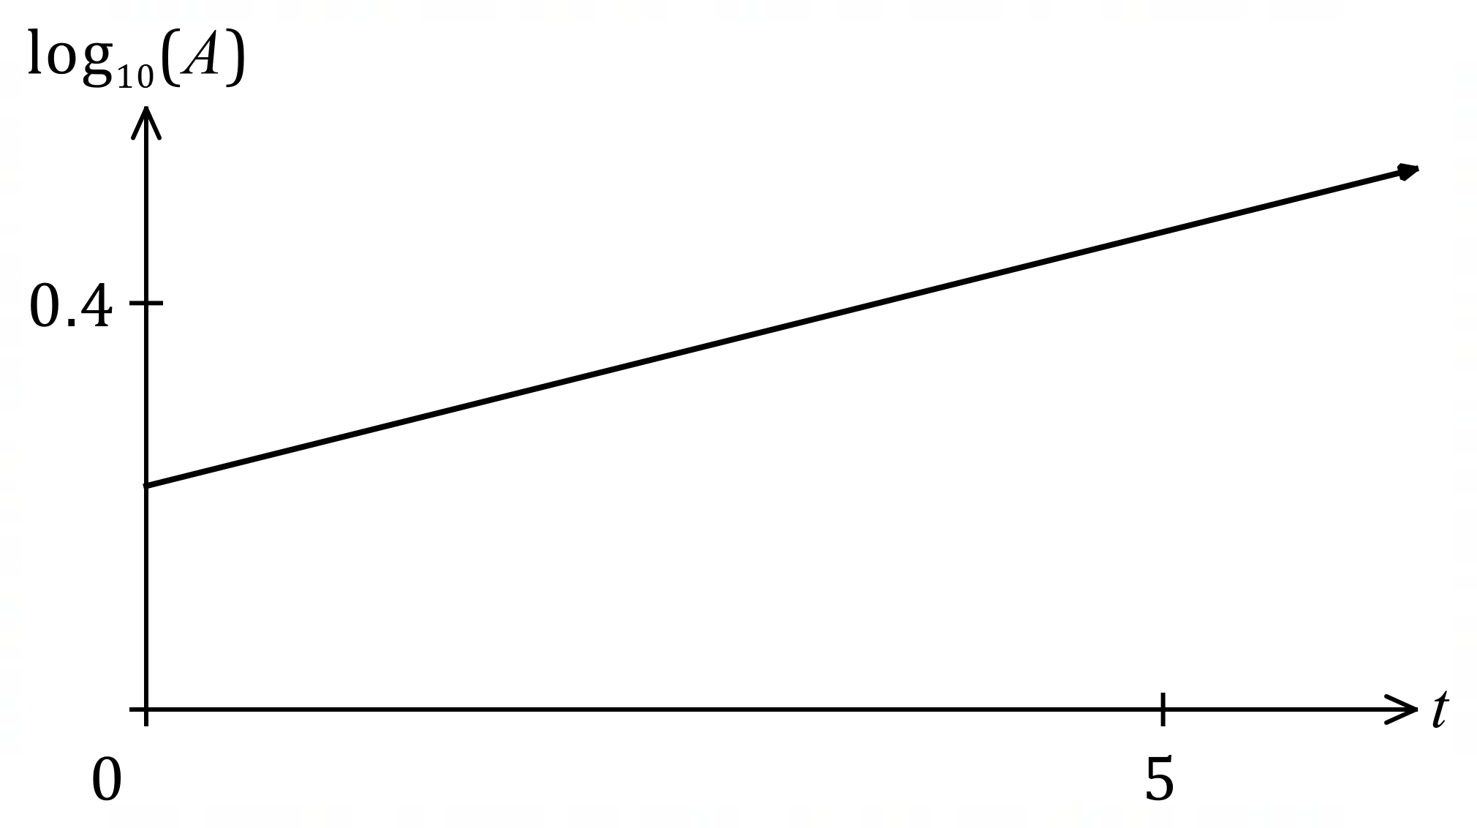

The line passes through $(1, 0.27)$ and $(6, 0.52)$.

(a) Use the two points to express $\log_{10}{A}$ as a linear function of $t$. (2 marks)
Solution
$$\text{slope}=\frac{0.52-0.27}{6-1}=0.05$$
Function:
$$\log_{10}{A}-0.27=0.05\left(t-1\right) \\ \log_{10}{A}=0.05t+0.22$$

Specific behaviours
correct slope
ü correct equation

(b) Determine the area of the bloom when $t=18$. (2 marks)
Solution
$$\log_{10}{A}=0.05\left(18\right)+0.22=1.12⇒A={10}^{1.12}=13.18 \text{ha}$$

Specific behaviours
converts log equation to exponential equation
ü correct area

The area of the bloom can be modelled by the equation $A=A_{0}r^{t}$, where $A_{0}$ and $r$ are constants.

(c) Determine the value of $A_{0}$ and the value of $r$. (3 marks)
Solution
$$A=A_{0}r^{t}⇒\log_{10}{A}=\log_{10}{A_{0}}+t\log_{10}{r}$$

Comparing to equation in part (a):
$$\log_{10}{A_{0}}=0.22⇒A_{0}={10}^{0.22}=1.66$$

$$\log_{10}{r}=0.05⇒r={10}^{0.05}=1.122$$

Specific behaviours
uses logs to change form of model
ü correct value of $A_{0}$
ü correct value of $r$

(d) Interpret the value of $r$ in the context of the model. (1 mark)
Solution
The area is increasing by $12.2\%$ each hour.

Specific behaviours
interprets as rate of increase of area, stating rate

(e) Determine the time the bloom takes to double in size. (2 marks)
Solution
$${1.122}^{t}=2⇒t=6.02 \text{h}$$

Specific behaviours
indicates equation for $r$ to double
ü correct time

Question 16 (8 marks)
The depth of water $h$ cm in a cylindrical water tank with an overall height of $95$ cm and a circular base of radius $21$ cm is increasing with time $t$ minutes, where $0≤t≤37.5$.

The depth of water is initially $6$ cm and changing at a rate given by $\begin{matrix}dh \\ \overline{dt}\end{matrix}=1.15\sqrt{t}-\begin{matrix}t^{2} \\ \overline{\overset{ }{200}}\end{matrix} .$

(a) At what rate is the depth of water increasing after $4$ minutes? (1 mark)
Solution
$$\frac{dh}{dt}=2.22 \text{cm/min}$$

Specific behaviours
correct rate

(b) Determine the volume of water in the tank after $9$ minutes. (3 marks)
Solution
$$Δh=\int_{0}^{9}{\left(1.15\sqrt{t}-\frac{t^{2}}{200}\right)}dt \\ =19.485$$

$$V=π{\left(21\right)}^{2}\left(19.485+6\right) \\ =35 308$$

Volume of water in tank is $35 308$ cm³.

Specific behaviours
correct integral for total change in height
ü correct change in height
ü correct volume of water

(c) Determine the time, to the nearest second, when the tank will contain $100$ litres of water.
Note that $1$ litre is equal to $1000$ cm³. (4 marks)
Solution
$$h=\frac{100 000}{π{\left(21\right)}^{2}}=72.179$$

$$Δh=\int_{0}^{T}{\left(1.15\sqrt{t}-\frac{t^{2}}{200}\right)}dt=\frac{23\sqrt{T^{3}}}{30}-\frac{T^{3}}{600}$$

$$\frac{23\sqrt{T^{3}}}{30}-\frac{T^{3}}{600}=72.179-6 \\ T=23.668$$

The tank will contain $100$ L after $23$ minutes and $40$ seconds.

Specific behaviours
calculates required height
ü integrates to obtain height function
ü forms equation for time
ü correct time, to nearest second

Question 17 (7 marks)
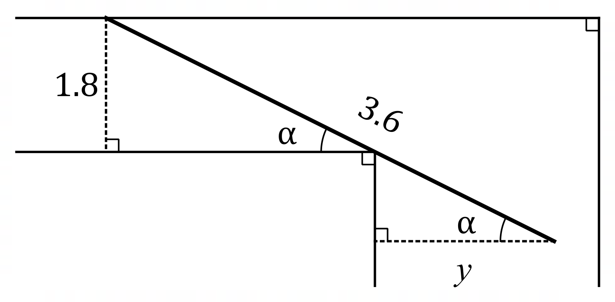
A corridor in a building is $1.8$ metres wide and meets
a second corridor at right angles. The diagram shows
a straight pipe, of length $3.6$ metres and negligible width,
being carried horizontally around, and just touching, the
corner. One end of the pipe touches the outer wall of
the first corridor and the other end protrudes $y$ metres
into the second corridor. The angle between the pipe
and the wall of the first corridor is $α$.

(a) Show that $y=3.6\cos{α}-1.8 \begin{matrix}\cos{α} \\ \overline{\sin{α}}\end{matrix}$ metres. (2 marks)
Solution
Let $x$ be length of wall from foot of perpendicular to corner in first corridor:

$$x\tan{α}=1.8⇒x=1.8\frac{\cos{α}}{\sin{α}}, x+y=3.6\cos{α}$$
Hence
$$y=3.6\cos{α}-1.8\frac{\cos{α}}{\sin{α}}$$

Specific behaviours
one correct relation, with any introduced variable(s) defined
ü clearly shows derivation of formula for $y$

(b) Use calculus to determine, with justification, the angle $α$ that maximises the distance $y$.
(4 marks)
Solution
First derivative of $y$ wrt $α$:
$$y^{'}\left(α\right)=-3.6\sin{α}-1.8\left(\frac{-\sin{α}\sin{α}-\cos{α}\cos{α}}{\sin^{2}{α}}\right) \\ =-3.6\sin{α}+\frac{1.8}{\sin^{2}{α}}$$
For stationary point:
$$-3.6\sin{α}+\frac{1.8}{\sin^{2}{α}}=0⇒\sin^{3}{α}=0.5⇒α=0.9169$$
Nature of stationary point:
$$y^{''}\left(0.9169\right)=-6.57$$

Since $y^{''}\left(0.9169\right)<0$ then the curve is concave down and as $y^{'}\left(0.9169\right)=0$ there is a local maximum when $α=0.9169$.

Specific behaviours
obtains $y'(α)$ in any form
ü solves $y^{'}\left(α\right)=0$ to obtain $α_{CRIT}$
ü obtains correct value for $y''(α_{CRIT})$
ü justifies $α_{CRIT}$ maximises $y$

(c) What is the minimum width of the second corridor for the pipe to pass around the corner?
Solution
$$y=3.6\cos{0.9169}-1.8\frac{\cos{0.9169}}{\sin{0.9169}}=0.81$$
The minimum width of the second corridor is $0.81$ metres.

Specific behaviours
correct minimum width

(1 mark)

Supplementary page

Question number: _________

Supplementary page

Question number: _________

© 2024 WA Exam Papers. Kennedy Baptist College has a non-exclusive licence to copy and communicate this document for non-commercial, educational use within the school. No other copying, communication or use is permitted without the express written permission of WA Exam Papers. Regular Paper SN245-245-4.

